BROCHURE WRITTEN BY:

ADD LOCAL STAFF NAMES ALSO

Christine Kowalski, MPH

VA Ann Arbor Healthcare System

Mohamad Fakih, MD, MPH

St. John Providence Health System

Sarah Krein, PhD, RN

VA Ann Arbor Healthcare System

The University of Michigan

Russ Olmsted, MPH, CIC

St. Joseph Mercy Hospital

Sanjay Saint, MD, MPH

VA Ann Arbor Healthcare System

The University of Michigan

HSR&D: Translating Research into Improved Patient Care

**VA Ann Arbor Healthcare System**

**HSR&D (152)**

**P.O. Box 130170**

**Ann Arbor, MI 48113-0170**

http://www.va.gov/annarbor-hsrd/

http://www.med.umich.edu/psep



What Patients and Family Members

Need to Know

About the Risks Associated with Urinary Catheters

**WHAT IS A URINARY CATHETER?**

Urinary catheters are used when a person cannot empty his or her bladder either because something is blocking the urine flow or the bladder does not feel the need to empty. Urinary catheters may also be used during and shortly after some types of surgeries.

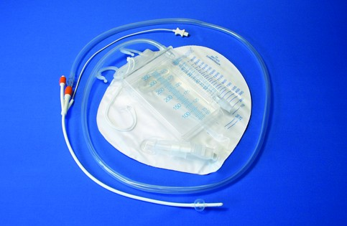

**WHEN SHOULD YOU NOT RECEIVE A URINARY CATHETER?**

Urinary catheters should not be placed just because you cannot get out of bed or because you leak urine (meaning you are “incontinent” of urine). There are other more safe measures that can be used instead.

**WHAT ARE THE RISKS OF A URINARY CATHETER?**

Urinary catheters can be harmful. They can hurt the bladder and cause you to feel pain below your belly button. Also, urinary catheters cause urinary infections which could spread to your blood and lead to a longer stay in the hospital.

How do you get an infection from your urinary catheter? Germs can travel along the catheter to your bladder or kidneys.

Urinary catheters can tend to limit your movement in bed and in your room. Limited activity will make you weak. Also, urinary catheters can be uncomfortable.

**WHAT ARE SOME ALTERNATIVES TO A FOLEY CATHETER?**

A temporary catheter can be put in your bladder and then removed within minutes. Alternatively, men can use an external catheter (also known as a “condom-style” catheter) that is placed over the penis rather than in it.

**I JUST HAD SURGERY OR I DO NOT FEEL LIKE I CAN GET OUT OF BED. SHOULD I REQUEST A URINARY CATHETER?**



If your doctor believes it is important for you to have a urinary catheter he or she will tell you. One of the best ways to recover after surgery or while you are staying in the hospital is to get up and move as soon as your doctor says that it is fine to do so. Research shows that sometimes urinary catheters can interfere with your movement. So, unless your doctor tells you the urinary catheter is necessary, it would be best for you not to have one.

**IF YOU ALREADY HAVE A URINARY CATHETER WHAT CAN YOU DO?**

Ask your doctor or your nurse every day if your urinary catheter is still necessary. The sooner it is removed, the lower your risk of infection and the sooner you can increase your mobility.

Make certain you know how to care for your urinary catheter and keep it clean. If you do not know how to do this, please ask your nurse or doctor today. Wash where the catheter enters your body every day with soap and water.

Clean your hands with soap and water or alcohol-based hand rub before and after touching your urinary catheter.

The urine drainage bag from your urinary catheter should stay lower than your bladder (your bladder is just below your belly button) at all times to prevent the urine from flowing back up into your bladder. This helps to prevent infection. If you notice that your drainage bag is too high, please tell your nurse.

You have a role in preventing infection!